**EYE BLINK/WINK BASED INTERACTION FOR DISABLE PATIENT**

**ABDUL MOEEZ KHAN**

**MALIK MUHAMMAD USMAN**

**MUHAMMAD UMAIR**

**MUHAMMAD HAMMAD RASHID**

**RAHIM AHMED**

**A project report submitted in partial fulfilment of the**

**Requirements for the award of the degree of**

**Bachelor of Computer Science**

|  |
| --- |
|  |

# Abstract

*The field of Human-Computer Interaction (HCI) has seen a gigantic development in the previous decade. The approach of tablet PCs and mobile phones permitting gaze based control has been hailed warmly. The specialists in this field have likewise explored the capability of 'eye-gaze' as a conceivable means of interaction. Some business arrangements have just been propelled, however they are so far costly and offer restricted ease of use. This paper endeavors to display a minimal effort ongoing system for eye-gaze Interaction for physically disabled patients so they can also remain connect with the world activities. Our project encourages the introduction of a real-time low-cost system for human-computer interaction based on perception. In the medical field “Eye Tracking” is an important area, especially in psychiatry to give an idea of patients with mental disorders. Today, the availability of many kinds of devices with powerful equipment’s can provide a way to analyze whether the use of these machines can be traced without using any extra components. Our project will attempt to find out the possibility of “Tracking eye using computers and webcam”. To complete this application, “Haar Classifiers” and “Tracking of Eye” algorithms are applied, template matching and bring out the eye using “Image gradients”. Our application was also applied as an independent activity in the background to analyze the effectiveness, performance and easiness of these two methods. “Haar classifiers”, “Template matching”, and “Eye detection” using chromatography algorithms show favorable outcome.*

# Introduction

## What Disability is:

According to International Classification of Functioning, Disability and Health (ICF), disability can be defined as a limitation in a functional domain that arises from the interaction between a person’s intrinsic capacity, and environmental and personal factors [**Global Status Report on Disability and Development *Prototype* 2015**]. Along similar lines, the United Nations’ Convention on the Rights of Persons with Disabilities recognized “that disability is an evolving concept and that disability results from theinteraction between persons with impairments and attitudinal and environmental barriersthat hinders their full and effective participation in society on an equal basis with others”. (UN, 2007: Preamble).

## Background:

Disable people, who account for over 16% of the world’s population [1], face various difficulties in daily activities. Particularly, the severely motor-impaired individuals lose the ability to move and interact with their environment. As a result, they often suffer from social exclusion and in consequence fall into depression [Majaranta et al. 2012].

As field of HCI is growing very fast in current era so Eye Tracking is also becoming special interaction way for systems/computers. Many algorithms are designed for this purpose. Eye tracking Algorithm are collection of research engineers that provide access to eye movement, eye-pupil, eye-blink, eye-wink and many other information, its location within a certain time range and (if any) view. For example, you can use the information obtained in this way. Perform research on the user interfaces, read texts or the fruitfulness of a commercial announcement. Every day our vision is used intensively for many different purposes like reading, writing, watching and implementing and learning new things. But now we are aware of the complexity of the system. Visible people or eye movements are a technique that has been used for over 100 years in areas like psychology, medicine, interactions between people and computers, marketing and many more.

**Project Scope:**

Technique clarified in the project is non-obtrusive and user-friendly, as it doesn't require any kind of unique equipment or wires. In addition, it doesn't have any physical connection with the client. A cheap solution is accommodated for gaze tracking. A web-cam in workstation/laptop/PC is utilized as a capturing device. A software based arrangement is proposed for controlling mouse pointer utilizing 'eye wink/blink'.

It is a characteristic and productive method for communication with the PC. For the most part the technique for communication available is mind boggling and lumbering. Utilizing this strategy, for controlling mouse pointer expands the collaboration effectiveness and decreases multifaceted nature. This technique is a unique way for disabled people, for example, spinal cord injured, or paralyzed patients.

The Application will contain following.

1. Screen of grid icons with pictures.
2. The correspondent grid will be highlighted on user’s wink (left or right).
3. Perform operation on the basis of selected grid on user’s blink.



Figure 1 Basic Layout of application.

# Related Work

A number of eye-gaze tracking techniques are already available. Some researchers performed eye gaze tracking using the Electro-Oculography tracking technique. It takes advantage of the fact that an electrostatic field exists around the eyes which changes with eye ball movement and these small differences can be recorded with help of electrodes placed on the skin around eye. The use of electrodes makes this technique troublesome and not well-suited for everyday use, an application can be found in [3]. A detailed review of Electro-Oculography tracking technique is presented in [4]. Various methods have been developed based on tracking contact lenses. These systems perform very well, but they are invasive, uncomfortable, and often require a topical anesthetic. “Matin and Pearce (1964) developed a scleral contact lens system that uses a pair of non-co-planar 4-mm-diameter mirrors embedded in the surface of the lens on opposite sides of the pupil, their system has a resolution of 0.00028 within a range of 10 for all three dimensions” [5]. A laser-based eye-tracking system is proposed in [5], it falls under the category of head-mounted eye tracking systems, which is not favorable for everyday use. Other examples of head mounted trackers are [6], [7].

Video-based systems have also been reported in literature. In past, low processing power of computing devices limited the use of video-based techniques for Eye Gaze Tracking as computing devices did not had the potential to provide real time eye gaze tracking operation. In last few decades, high processing power computing devices have been made available which motivated the researchers to develop video-based solutions for Eye Gaze Tracking. Several video-based system methods have been reported in literature, a few of them are Corneal Reflections [2], Purkinje Image tracking [8]. This paper likewise introduces a video-based gaze tracking system furthermore, endeavors to take an edge of web-cam in PC for gaze tracking. It shows a solution utilizing Computer vision and image processing algorithm. This is an endeavor to report a minimal effort eye gaze tracking system for Human Computer Interaction.

**Available Solutions in Market**

## Three-Dimensional Direction of Sight:

The 3rd category of eye track is known as oculogyric and 3Dimensional.In accumulation to the horizontal statistics and the perpendicular divergence of eye, the information about rotation (turning round) about its axis. For few machines, we can manage the movements and location of head, with the help of that we can get the data of location of eyeballs (rotational axis of eyeball). The products of this problem are the GCSMI “German company Sensor Motoric Instruments” GmbH. It's a bold 3D device that follows your eyes.



Figure 2 Heat map eye test results

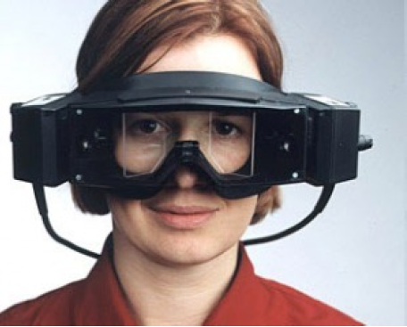

Figure 3 3DVideo system

## Electro-Eye Tracking

The diversity methodology involves calculation of the region of the skin around the eyes attached to the potential use poles. It can be a place for the eye to detect a pinpoint, when they remembered thanks to the skin, a small amount of variations in the potential accuracy. But this is not enough to require the use of the skin, using the art of Figure 4 with the unpleasant or exists closest to the electrodes to be seen. For this is the manner of the most widely used solution to the 40 years, it is not yet you will find on the application. A very different way of measuring the tension of the eyes muscles of the competition. Depending upon breadth of the ample that traverses the measurements between the eyes rapid fluctuation in the site (called "saccades"). This is mainly thanks to the effort on the eye-ball is different by the back of our potential. System's sensible sound is mainly based on an act other muscles his face. Electric eye tracking there is often used in medicine. The changes to be made in the fields of electric charge of eye movement control means allows in its place.

## Contact Lenses Used By Technicians.

The use of special contact lenses made it easier to effectively find out the eyeball motion. There are lenses such as small induction coils. Making the lens positioning precise it is done by recording the changes E-M field caused by eye movement. Problem arises in head movements. Major disadvantage is restriction of traffic and non-bulky devices, which makes it to be only used for laboratory purposes.

## Using Infrared Light

Infrared illumination of the eye facilitates some local dog walking in the optical axis [9]. RENICO almost all this phenomenon reflects the light that makes the room for each tablet on a white figure 4 similar to the red eye. Infrared light source of infrared light outside the optic axis of the eye, Figure 4, the method consists of the dark place, eye cameras identifying the eye retina center and the location between the shining sources of the cornea from the infrared light. Recipients of light return various structures called receptor image (Figure 5.Purkinje images). Marks light reflection on the eye of the developer with the corneal vision (it was called the 1 Light grunt image receptor P1) to mention that the pupil's Middle is high. The accuracy of the measurement can be increased price and the number of registered points of the users in the quartile, is the device (gleam). There are also devices, and the correct measurements have two receptors (double eye of the developer's eye) for use in light images of the developer's corneal surface

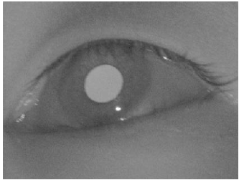

Figure 4 Shining effect caused by the source

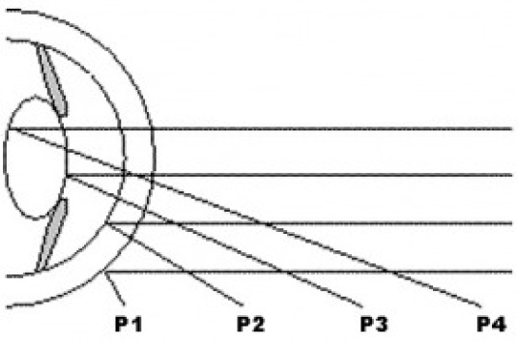

Figure 5 Purkinje images

.i,e the first image receptor P1 on the rear face of the lens (the fourth image receptor P4) is based. The special effects or the beard generally support teething (bit-bar) thanks to the use of tuition.

## Absence of Infrared Light

By using a standard camera an image is recorded. The reason for this activity is that the position and shape of the cornea are measured according to the standard part of the group (e.g., the angle of the eye). Corneal mucus is usually a damaged element. The solution, which is part of the following verse, places the apple on the ground with a horned envelope. However, the contrast between the corneas is much smaller than the rest of the mouth and eyes. Otherwise, it uses a neural network. Know with foot max. This kind of system calibration procedure takes a long time. You need to judge a large amount of images to learn the correct neural network. In fact, most languages used by the camera assume that the user has the actual test header. To ensure free movement of the head, the current position of the head (displacement and short circles) is more accurately determined by the developer.

Consider the eye and the point on the screen for a certain moment of the person. The calibration of these systems takes a long time. It requires a large number of trained images for the neural network learning. Systems based on the use of a standard video camera generally assume that the user still maintains an ideal head during the test. To allow freedom of movement of the head, it is necessary to determine the precision in the implementation of the current methods of head position (compensations and short circuits).

## Existing Solution Review

There are many “Eye Tracking System” available in the market; the chief products are Tobii and SMI. These are remote systems, that is, no hardware is installed on the user's head. Its activities rely on the use of camera images in the infrared range and infrared light source. The current view is the difference between light and light. However, there is no trading system that runs on a standard application camera. This works among other things to create a less expensive “Eye Tracking System” using a standard camera. Currently, the available procedure is to handle the sight examination using a standard open gazer camera. It is an open source program. Its main drawback is assumption; the user header is completely silent while running the program. Even small movement makes it necessary to reset the system.

# SYSTEM DESCRIPTION

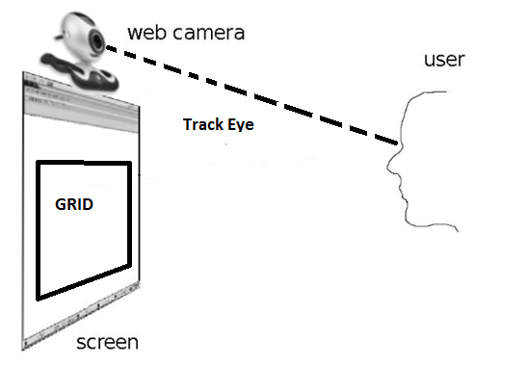

Figure 6 System diagram

It offers a vision control tool based mainly on the recording of ocular pixels with a popular network camera. Diagram of the tool appears in Figure 7. For ease, the web camera is placed on the screen in the middle of it. Most commercial structures require that the webcam be sited at bottom of the screen, which gives a better picture of the camera. However, it has become the aim of these paintings to find a global response. The webcam is usually at the top of the screen, for example, laptops with a built-in camera that cannot change. The reason for this action is to conclude the point on display that people are presently eyeing for. To find these records, miles must determine the correct place for eye and face. The first phase is to initialize algorithm, in which header version is formed. When initialization, follow tracking section. To locate the 3D head, an optical flash is used between successive structures gained from the webcam and the POSIT algorithm [12]. An alternative is determined in the visual path using reading variances within the distance between the middle of the eye. These data are gained by means of a complete set of procedures of image identification within the relaxation of the paintings. For results presents, a complete set of algorithms was examined, some of which go to the foreground in the next work.

## Tracking Algorithms

## Algorithm For Eye and Head Recognition.

1. Look for a picture used in the EMgu lib. To discover the head. Result is the position.

Find all head larger head is integrated for additional testing size, that is, the user closest to the webcam.

2. Via head locations formerly selected, following EMgu lib. Is use to expose the eye. To reduce CPU load, only the superior half of head is searched. Also reduce the threat of improper eye recognition, p. For example, position your mouth or nose.

3. Estimate the relative size of head and eye in exact position. The size of the eyes and eyes horizontal role should be close to one another. When they are no longer fulfilled, complete recognition requirements in the new cage are performed from the beginning.

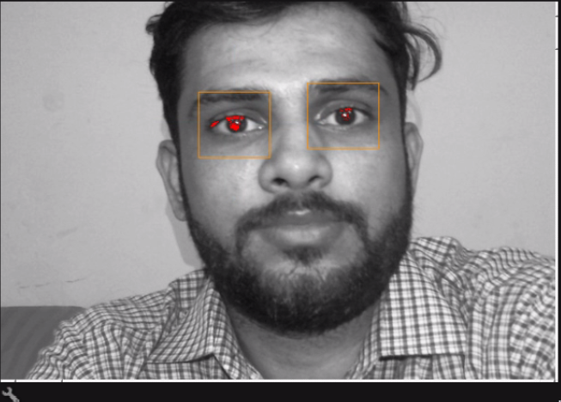

Figure 7 Facial features detection

The solution of the implemented algorithm in the form of combined EMgu lib./class, this layer process for facial and eye recognition sequences with many high visual effects can be seen in figure 8. On the behalf of implementations “we can conclude that most of facial features of the HAAR effects and their error like, for example, the position of the image where no face and eyes are recognized or may be wrongly settled in front of webcam. This situation usually occurs when lighting situations regardless of the images are placed wrong, To illustrate the magnificence of EMgu calculated the use of the final result is wrong and basically concluded with the face head lighting devices, However, the regions expected their eyes size is a reliable process of the algorithm, the fact that sometimes images which are given in a data set of algorithm will not be found, however it’s not a big deal, this application will utilizes the video sequences and we can neglect the initial frame, the facial features algorithm is implemented frequently until and unless facial features like eyes and face are to be detected and until and unless their mutual positioning conditions are met.

**Working:**

Visual-based eye wink machine have a lot of likely applications. System interface& lie recognition. It does not an issue, what the goal of a machine is to develop an improved algorithm stable, reliable works in actual time with changing igniting terms [12].

Visual-based wink detection machine is based on the components available for sale: A PC or laptop is of average quality, Webcam. Lower face images (320 * 240

Pixels) processed at approximately 30Fps. The four steps of Detection Blink of eye are following.

* Detection of Face.
* Extract out eye region.
* Detection of Eye.
* Classify Wink

Face recognition is implemented with the help of features similar to Haar and a set of improved tree workbooks. The location of the eyes depends on certain geometric relationships known to face. Eye wink recognition is implemented with template comparison method. Algorithms are defined in greater in detailed below. Algorithm helps in detecting eye wink. Evaluation of the duration of the wink of an eye and on behalf the grouping of eyelash in kind as intended.

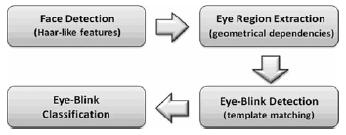

Figure 8 Scheme of the proposed algorithm for eye-blink detection

## Facial Features Recognition

Face recognition is a very important part of the development of the Wink Scout set. This is due to the fact that the face recognition site is arithmetically expensive and therefore takes a long time. This procedure is simpler if the system is configured and if the miles are permanent. The face is "misguided". So for a machine that works in real time, you need the specific way to work fast (much less than just).

On the other hand, the accuracy of your focus is also on the dynamic payment must be subject to high recognition fees, error detection and price errors. The chosen method must work well under fine light conditions.

Facial expressions, head formation, partial facial blockage, glasses, facial hair and. Different hairstyles have been suggested by many answers. The face detector can be divided into:

Knowledge-based strategies use simple guidelines to describe houses of facial symmetry, engineering, and facial faculty relationships. [12]

• The working methods are based on eye detection

• nose or pores and skin color [11],

• Combination of existing template techniques in the calculation of the relationship between image input and stored face patterns [11]

• Based on the model. Methods in which algorithms are fashioned in a fashionable way.

Use neural networks [12], assisting disease vector machines (SVM) [12] or hidden markov models (HMM) [12]. Inan Algorithm has developed the method derived from the template. A matching set developed with Viola and Jones has been changed [11]

By Leinchart and Maydt, finished according to us. Similar houses are calculated with hair by distributing pictures with templates of different length and direction (figure. 4). These prototypes can be divided into three categories: boundary, line, and centering on the masks. Everything should be formed [12].

## Detection of Eye

Meanwhile the algorithm will detect an image point from a source image through which it detects eyes. It depends entirely on some of the known technical dependencies of the human face. Traditional percentage rules the face, when divided into six equal squares, appears two by three [2]. According to these guidelines, eyes are localized. About. Four ways from the highest peak to the eyes, a picture of the eye area pulled out. Pretreatment of eye blink detection. The local eye area is extracted from the face image. It is used as a model for further eye tracking through matching templates. The attention extraction was completed in the tool configuration and in better [12].Cases where facial recognition is repeated.

## Extract Out Eye-Region

Recognized eye are detected by using normal reciprocal relation. Eye are spontaneously obtained through initiating ofMachine.

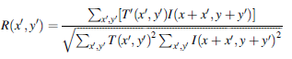

Where (“R”) correlation coefficient[12], T image template[12], the original me The coordinates of the image are x and pixel. Coefficient of correlation, It is a measure of the current eye resemblance.

## Classify Eye-Wink

The correlation coefficient is analyzed in good time to face an arbitrary ambiguity of more than 250 milliseconds. If the parameter cost for two consecutive steps within the pixel is lower, the threshold is determined. Pay attention to eyelashes if the link costs from the parameter are larger than the Threshold price. TL and TH thresholds have been set. If the detection length is longer than 250 milliseconds and shorter than two seconds, this flash is considered "voluntary manipulation"

## Application Flow Diagram

The flow diagram given below defined the structure of our application.

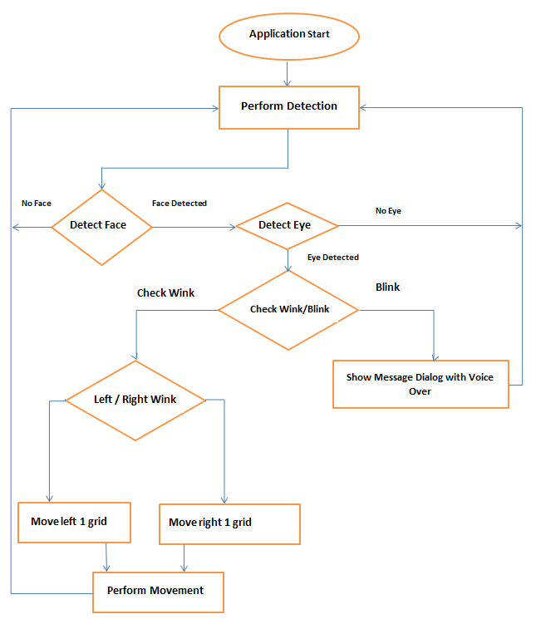

# Result and Discussion

The system development for the detection and control of winks was tested using the IntelCoreQuad CPU at 2.4 GHz in the USB sequence of Logitech. The webcam size of QuickCam 9000 Pro is entered. The sequence corresponded (“320 * 240”) pixels test of the system tested in a room, lit 3 fluorescent lights and natural light by a window. They sat in front of the screen, and their instructions came in contact to wink every 40 times (“20 long winks and 20 short winks”). Camera is installed at the topmost position of screen. At a distance of 50 cm by the face, the wink was real-time at regular speed of 30 frames per second. Two types of faults was recognised: error detection (machine recognized wink, if not present) lost token (the system did not recognize the current blink). The possible dissemination of the result for recognizing the wave form is shown in the form of diagrams in Figure 9. 1Blinks are correctly called TP, false positives are called False Posi figure 9.

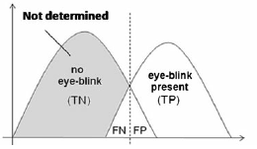

Figure 9 Possible distribution of the eye-blink detector output



Figure 10 Command pass when double blink



Figure 11 Moving left or right by eye wink

# Conclusion

Automatic detection algorithm for voluntary winks, i was working in the advancement of interface. C# applications, optical

Study Library &Emgu CV. Application was made from rack parts: Internet, camera and user’s PC. For efficient results space b/w webcam & Face shouldn’t be higher from 1ft.

Application Configuration can be viewed in Figure 12.



Figure 12 Application Interface

The suggested interface is triggered by optional tabs the average duration of spontaneous winks is equals about 100ms. Detected winks are described as minimum and maximum in [12] way to deduce faults initiated by the elucidation, winking of eye more than 200 milliseconds is considered "control". Some are execute as orders for the application program to Example diagram to open the eyes in time with small & large wink.

The application is developed for Window operating system. It has the following features:

* Calling Doctor
* Need Food
* Want to read News
* Need to go to toilet
* Need water
* Need a nurse

The main items for disabled patients are calling doctor, need of a drinking water, a need of nurse; want to read a News and need to go to toilet all these operation can be performed with the help of winks, as in this application winks accuracy is approx... 83% and it is easily usable application.

There are lots of applications available for Blink Detection. Tobii Eye is one of the examples for this application but it is not affordable for every person.

In this FYP we developed a webcam based application which uses Haar classifier/Algorithm for wink and wink detection and we recommend this as it is very less expensive than Tobii devices. We can also install it on Raspberry Pi & more accurate, which will assist disable patients to convey their message easily.

**References:**

[1] World Health Organization, 2011 report. <http://www.who.int/disabilities/world_report/2011/report/en/>

[2] D. H. Yoo, J. H. Kim, B. R. Lee, and M. J. Chung, “Non-contact Eye Gaze Tracking System by Mapping of Corneal Reflections,” in *Fifth IEEE International Conference on Automatic Face and Gesture Recognition (FGR02)*, 2002, pp. 94-99.  
[3] Rafael Barea, Luciano Boquete, Manuel Mazo, and Elena Lpez, “System for assisted mobility using eye movements based on electrooculography,” *IEEE TRANSACTIONS ON NEURAL SYSTEMS AND REHABILITATION ENGINEERING*, vol. 10, no. 4, pp. 209-217, DECEMBER 2002.  
[4] H. Singh and J. Singh, “A Review on Electrooculography”. *International Journal of Advanced Engineering Technology*, vol. III, no. IV, 2012.  
[5] K. Irie, B. A. Wilson, and R. D. Jones, “A laser-based eye-tracking system,” *Behavior Research Methods, Instruments, & Computers*, vol. 34, no. 4, pp. 561-572, 2002.  
[6] P Ballard and George C. Stockman, “Computer operation via face orientation,” in *Pattern Recognition, 1992. Vol.I. Conference A: Computer Vision and Applications, Proceedings., 11th IAPR International Conference on*, 1992, pp. 407-410.  
[7] T. Horprasert, Y. Yacoob, and L.S. Davis, “Computing 3-D head orientation from a monocular image sequence,” in *Second International Conference on Automatic Face and Gesture Recognition*, 1996, pp. 242- 247.  
[8] K. Arai and M. Yamaura, “Computer Input with Human Eyes-Only Using Two Purkinje Images Which Works in a Real-Time Basis without Calibration,” *CSC Journals*, vol. 1, no. 3, pp. 71-82, 2010.

[9] H. Singh and J. Singh, “A Review on Electrooculography,” International Journal of Advanced Engineering Technology, vol. III, no.IV, 2012.

[11] P. Viola and M. Jones, “Rapid Object Detection using a Boosted Cascade of Simple Features,” in COMPUTER VISION and PATTERN RECOGNITION, 2001.

[12] R. Kothari and J.L. Mitchell. Detection of eye locations in unconstrained visual images. In Image Processing, 1996.Proceedings., International Conference on, volume 3, pages 519–522 vol.3, Sep 1996. doi: 10.1109/ICIP.1996.560546.

[11]Opencv - object detection. <http://docs.opencv.org/modules/imgproc/doc/> object_detection.html.Accessed: 2015-05-20.

[12]Królak, A., andStrumiłło, P. (2011).Eye-blink detection system for human–computer interaction. *Universal Access in the Information Society,* *11*(4), 409-419. doi:10.1007/s10209-011-0256-6